

Ain Shams University – Faculty of Engineering I-CHEP

University of East London - Computer Engineering and Software Systems Program

Web Development
CSE361

Internet Programming
CESS5005

Lab Assignment
Submitted to:
Dr. Islam Tharwat Abdel Halim
Date: November 4, 2025

Lab 2 submission:
index.html:
<!DOCTYPE html>
<html lang="en">
<head>
<meta charset="UTF-8" />
<meta name="viewport" content="width=device-width, initial-scale=1.0" />
<title>Omar Alashker | Portfolio</title>
<link rel="stylesheet" href="style.css" />
</head>
<body>
<header>
<h1>Omar Alashker</h1>
<p>Web Developer | Student</p>
<nav>
<ul>
<li><a href="#about">About</a></li>
<li><a href="#projects">Projects</a></li>
<li><a href="#contact">Contact</a></li>
</ul>
</nav>
</header>

<main>
<section id="about" class="section">
<h2>About Me</h2>
<p>
Hello! I'm Omar, a passionate web developer with experience in
creating responsive and interactive websites. I love coding,
designing, and bringing ideas to life on the web.
</p>
</section>

<section id="projects" class="section">
<h2>Projects</h2>
<div class="projects">
<div class="card">
<h3>Travelling-Website</h3>
<p>
Travelling Website is a front-end travel-themed website designed
to inspire and assist users in planning their dream vacations.
</p>
</div>
<div class="card">
<h3>Sorting-Visualizer</h3>
<p>
A sorting viusalizer that includes sorting algorithms such as
"Bubble Sort", "Selection Sort", "Insertion Sort", "Merge Sort",
and "Quick Sort".
</p>
</div>
<div class="card">
<h3>Ecommerce_DB</h3>
<p>
This project contains the full relational database schema for a
fictional e-commerce platform.
</p>
</div>
</div>
</section>
</main>
</body>
</html>
style.css:
body {
margin: 0;
font-family: Arial, Helvetica, sans-serif;
background-color: #f7f7f7;
color: #333;
}
header {
background-color: #white;
color: white;
text-align: center;
padding: 40px 20px;
}

header h1 {
margin: 0;
font-size: 2rem;
}

header p {
margin: 8px 0 20px;
font-size: 0.95rem;
color: #bfbfbf;
}

nav ul {
list-style: none;
padding: 0;
margin: 0;
display: flex;
justify-content: center;
gap: 30px;
}
nav a {
color: white;
text-decoration: none;
font-size: 0.95rem;
}
.section {
text-align: center;
padding: 60px 20px;
}
#about p {
max-width: 650px;
margin: 20px auto 0;
line-height: 1.6;
color: #555;
}
.projects {
display: flex;
flex-wrap: wrap;
justify-content: center;
gap: 20px;
margin-top: 40px;
}
.card {
background: white;
padding: 20px;
border-radius: 8px;
width: 280px;
box-shadow: 0 2px 6px rgba(0, 0, 0, 0.1);
text-align: left;
}
.card h3 {
margin-top: 0;
font-size: 1rem;
}

.card p {
font-size: 0.9rem;
color: #555;
}
}

GUI:
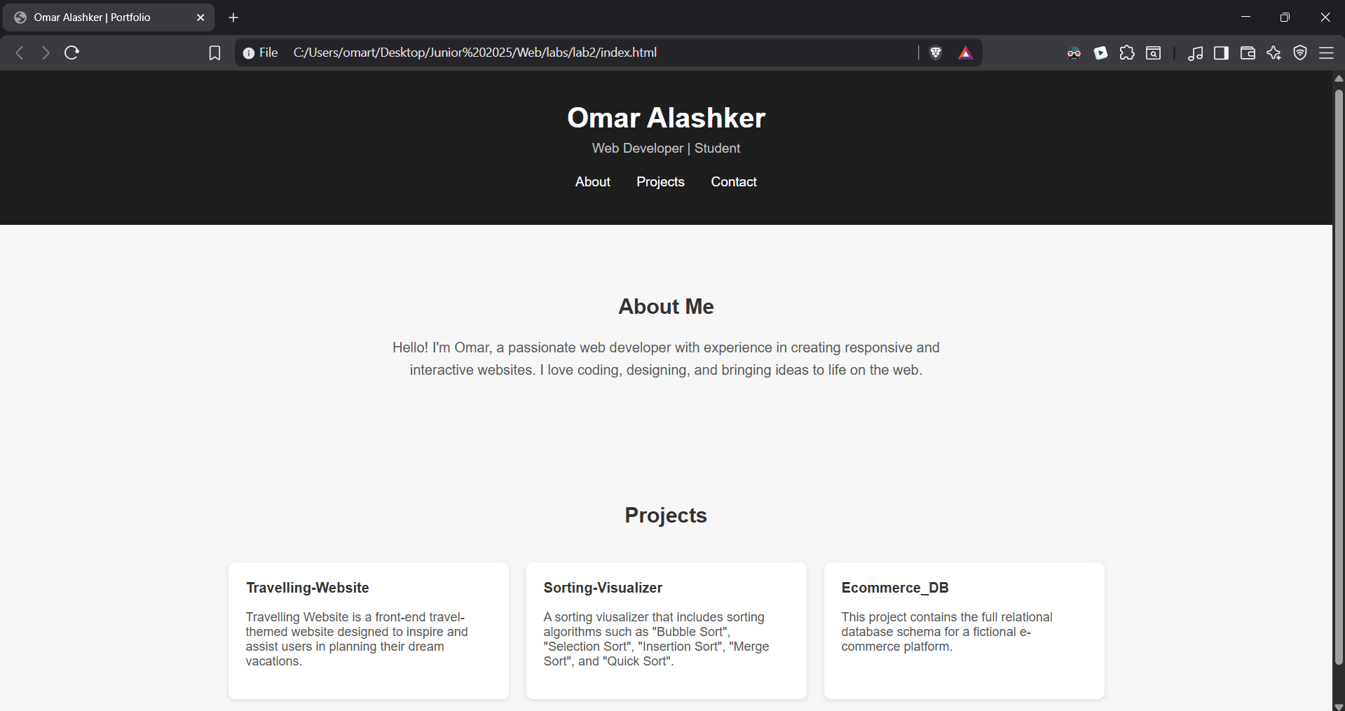
Lab 3:
Index.html:
<!DOCTYPE html>
<html lang="en">
<head>
<meta charset="UTF-8" />
<meta name="viewport" content="width=device-width, initial-scale=1.0" />
<title>Simple Calculator</title>
<link rel="stylesheet" href="style.css" />
</head>
<body>
<div class="calculator">
<h2>Calculator</h2>
<input type="text" id="display" readonly />

<div class="buttons">
<button class="btn" onclick="clearDisplay()">C</button>
<button class="btn" onclick="deleteLast()">←</button>
<button class="btn" onclick="append('%')">%</button>
<button class="btn" onclick="append('/')">÷</button>

<button class="btn" onclick="append('7')">7</button>
<button class="btn" onclick="append('8')">8</button>
<button class="btn" onclick="append('9')">9</button>
<button class="btn" onclick="append('*')">×</button>

<button class="btn" onclick="append('4')">4</button>
<button class="btn" onclick="append('5')">5</button>
<button class="btn" onclick="append('6')">6</button>
<button class="btn" onclick="append('-')">−</button>

<button class="btn" onclick="append('1')">1</button>
<button class="btn" onclick="append('2')">2</button>
<button class="btn" onclick="append('3')">3</button>
<button class="btn" onclick="append('+')">+</button>

<button class="btn zero" onclick="append('0')">0</button>
<button class="btn" onclick="append('.')">.</button>
<button class="btn equals" onclick="calculate()">=</button>
</div>
</div>

<script src="script.js"></script>
</body>
</html>

style.css:
body {
background-color: #f3f3f3;
font-family: Arial, sans-serif;
display: flex;
justify-content: center;
align-items: center;
height: 100vh;
}

.calculator {
background-color: #ffffff;
padding: 20px;
border-radius: 10px;
box-shadow: 0 4px 10px rgba(0, 0, 0, 0.2);
width: 260px;
}

h2 {
text-align: center;
margin-bottom: 15px;
color: #333;
}

#display {
width: 100%;
height: 50px;
text-align: right;
font-size: 1.4rem;
padding: 5px;
border: none;
border-radius: 5px;
background-color: #f0f0f0;
margin-bottom: 10px;
}

.buttons {
display: grid;
grid-template-columns: repeat(4, 1fr);
gap: 10px;
}

.btn {
padding: 15px;
font-size: 1.1rem;
border: none;
border-radius: 5px;
background-color: #e0e0e0;
cursor: pointer;
transition: background 0.2s;
}

.btn:hover {
background-color: #d0d0d0;
}

.equals {
background-color: #4caf50;
color: white;
}

.equals:hover {
background-color: #45a049;
}

.zero {
grid-column: span 2;
}
body {
background-color: #f3f3f3;
font-family: Arial, sans-serif;
display: flex;
justify-content: center;
align-items: center;
height: 100vh;
}

.calculator {
background-color: #ffffff;
padding: 20px;
border-radius: 10px;
box-shadow: 0 4px 10px rgba(0, 0, 0, 0.2);
width: 260px;
}

h2 {
text-align: center;
margin-bottom: 15px;
color: #333;
}

#display {
width: 100%;
height: 50px;
text-align: right;
font-size: 1.4rem;
padding: 5px;
border: none;
border-radius: 5px;
background-color: #f0f0f0;
margin-bottom: 10px;
}

.buttons {
display: grid;
grid-template-columns: repeat(4, 1fr);
gap: 10px;
}

.btn {
padding: 15px;
font-size: 1.1rem;
border: none;
border-radius: 5px;
background-color: #e0e0e0;
cursor: pointer;
transition: background 0.2s;
}

.btn:hover {
background-color: #d0d0d0;
}

.equals {
background-color: #4caf50;
color: white;
}

.equals:hover {
background-color: #45a049;
}

.zero {
grid-column: span 2;
}

script.js:
const display = document.getElementById("display");

function append(value) {
display.value += value;
}

function clearDisplay() {
display.value = "";
}

function deleteLast() {
display.value = display.value.slice(0, -1);
}

function calculate() {
try {
display.value = eval(display.value);
} catch {
display.value = "Error";
}
}

GUI:
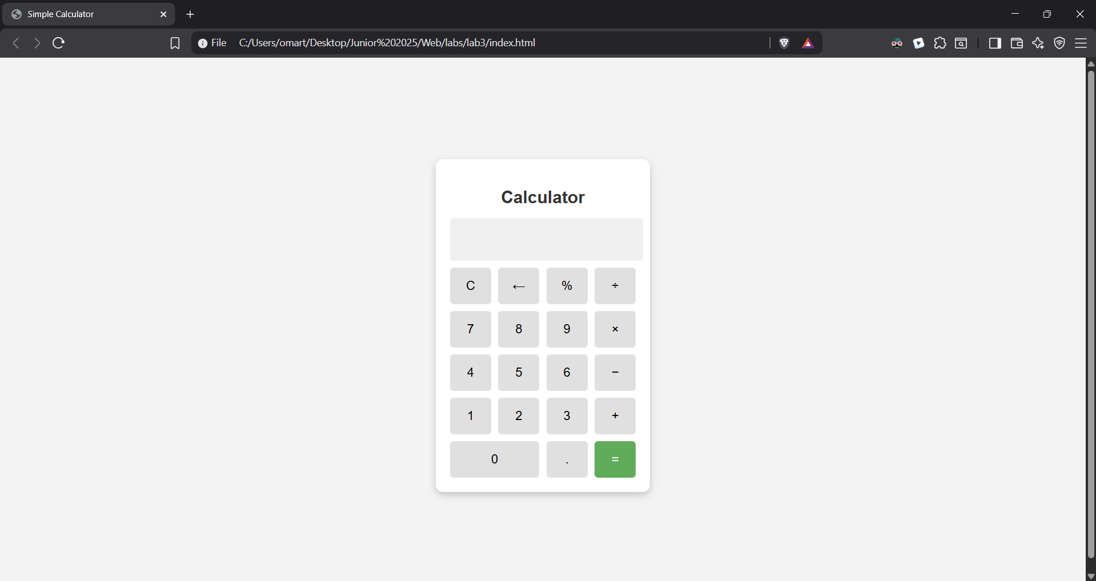

Lab 4:
Index.html:
<!DOCTYPE html>
<html lang="en">
<head>
<meta charset="UTF-8">
<meta name="viewport" content="width=device-width, initial-scale=1.0">
<link rel="stylesheet" href="styles.css">
<title>To-do List</title>
</head>
<body>
<h1>To-do List</h1>
<input type="text" id="task" placeholder="Enter a new task">
<button id="addTask">Add</button>
<button id="clearTasks">Clear All</button>
<ul id="taskList"></ul>
<script src="index.js"></script>
</body>
</html>

styles.css:
body {
background-color: rgb(213, 210, 205);
font-family: Arial, Helvetica, sans-serif;
}

.delete_btn {
margin: 10px;
}

index.js:
let taskInput = document.getElementById("task");
let taskList = document.getElementById("taskList");

document.getElementById("addTask").addEventListener("click", addTask);
document.getElementById("clearTasks").addEventListener("click", clearTasks);

function addTask() {
let taskText = taskInput.value;
if (taskText === "") return;

let li = document.createElement("li");
li.textContent = taskText;

let delete_button = document.createElement("button");
delete_button.textContent = "X";
delete_button.classList.add("delete_btn");

delete_button.addEventListener("click", function () {
li.remove();
});

li.addEventListener("click", function () {
if (li.style.textDecoration === "line-through") {
li.style.textDecoration = "";
} else {
li.style.textDecoration = "line-through";
}
});

li.appendChild(delete_button);
taskList.appendChild(li);

taskInput.value = "";
}

function clearTasks() {
taskList.innerHTML = "";
}

GUI:
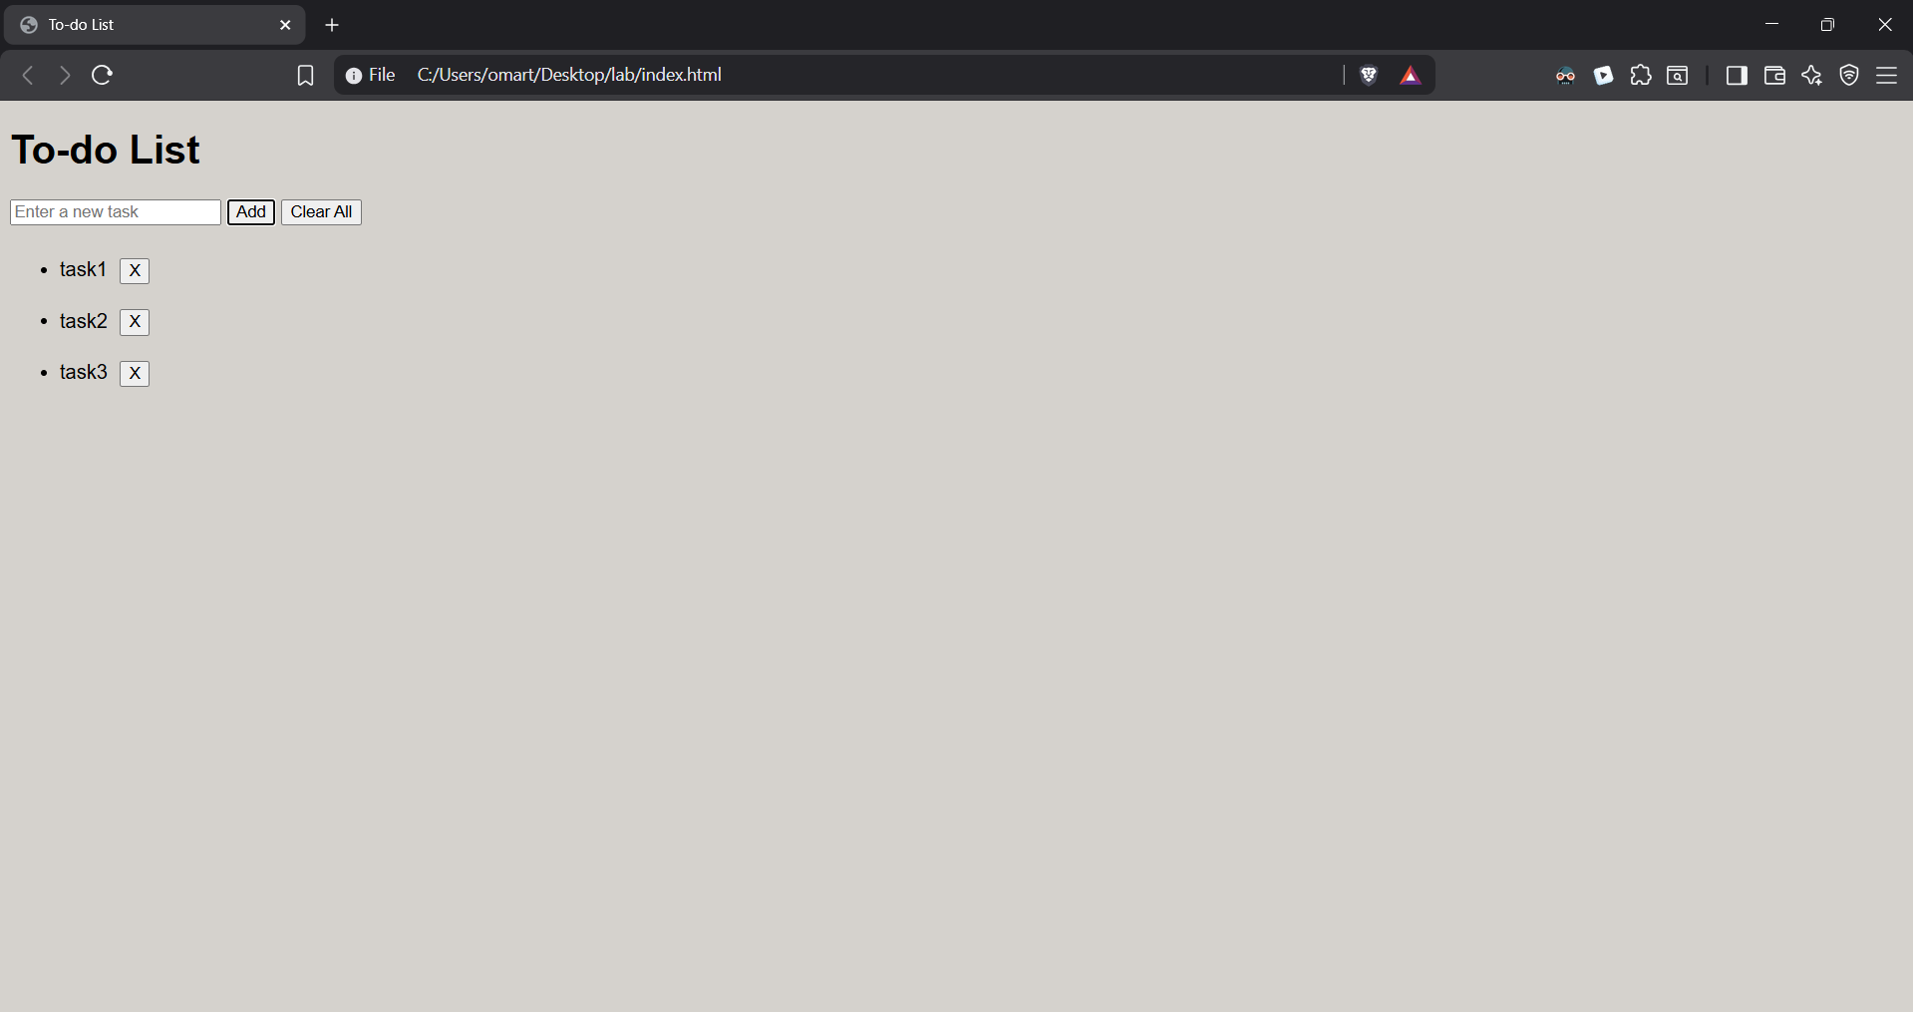

Lab 5:
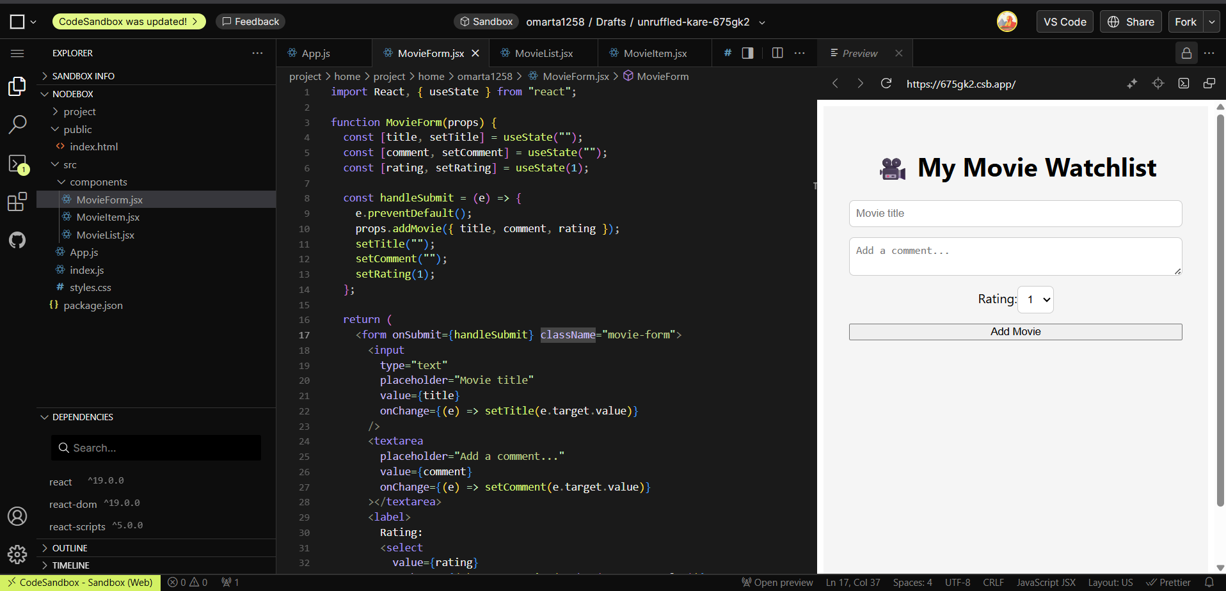
App.js:
import React, { useState } from "react";
import MovieForm from "./components/MovieForm.jsx";
import MovieList from "./components/MovieList.jsx";
import "./styles.css";

function App() {
const [movies, setMovies] = useState([]);

const addMovie = (movie) => {
setMovies([...movies, movie]);
};

const removeMovie = (index) => {
setMovies(movies.filter((_, i) => i !== index));
};

return (
<div className="app-container">
<h1>🎥 My Movie Watchlist</h1>
<MovieForm addMovie={addMovie} />
<MovieList movies={movies} removeMovie={removeMovie} />
</div>
);
}

export default App;

Movieform.jsx:
import React, { useState } from "react";

function MovieForm(props) {
const [title, setTitle] = useState("");
const [comment, setComment] = useState("");
const [rating, setRating] = useState(1);

const handleSubmit = (e) => {
e.preventDefault();
props.addMovie({ title, comment, rating });
setTitle("");
setComment("");
setRating(1);
};

return (
<form onSubmit={handleSubmit} className="movie-form">
<input
type="text"
placeholder="Movie title"
value={title}
onChange={(e) => setTitle(e.target.value)}
/>
<textarea
placeholder="Add a comment..."
value={comment}
onChange={(e) => setComment(e.target.value)}
></textarea>
<label>
Rating:
<select
value={rating}
onChange={(e) => setRating(Number(e.target.value))}
>
{[1, 2, 3, 4, 5].map((star) => (
<option key={star} value={star}>
{star}
</option>
))}
</select>
</label>
<button type="submit">Add Movie</button>
</form>
);
}

export default MovieForm;

MovieList.jsx:
import React from "react";
import MovieItem from "./MovieItem.jsx";

function MovieList(props) {
return (
<div className="movie-list">
{props.movies.map((movie, index) => (
<MovieItem
key={index}
index={index}
movie={movie}
removeMovie={props.removeMovie}
/>
))}
</div>
);
}

export default MovieList;

MovieItem.jsx:
import React from "react";

function MovieItem(props) {
const stars = "⭐".repeat(props.movie.rating);

return (
<div className="movie-item">
<h3>{props.movie.title}</h3>
<p>{stars}</p>
<p>{props.movie.comment}</p>
<button onClick={() => props.removeMovie(props.index)}>Remove</button>
</div>
);
}

export default MovieItem;

